Paper Title (Replace with Your Paper Title)
1st Author Name  Department/Institution Name  City, Country  author1@email.com | 2nd Author Name  Department/Institution Name  City, Country  author2@email.com | 3rd Author Name  Department/Institution Name  City, Country  author3@email.com
4th Author Name  Department/Institution Name  City, Country  author4@email.com | 5th Author Name  Department/Institution Name  City, Country  author5@email.com | 6th Author Name  Department/Institution Name  City, Country  author6@email.com

Abstract—This document is the official paper template for ICEAI 2026 (2nd International Conference on the Evolution of Artificial Intelligence). The abstract should be a single paragraph of 150–250 words summarizing the problem addressed, the proposed approach, and the key results/contributions of the paper. Do not include citations or undefined abbreviations in the abstract. The full paper, including title, author block, abstract, references, and appendices, must not exceed six (6) pages in this two-column format.
Keywords—component; formatting; style; styling; keyword one; keyword two; keyword three (list 4–6 keywords separated by semicolons)
I. INTRODUCTION
Provide the background and motivation for the work. Clearly state the problem being addressed, why it is important, and how existing approaches fall short. Summarize the paper's contributions as a short, itemized list where possible, and outline the structure of the remainder of the paper (e.g., "Section II reviews related work; Section III presents the proposed methodology; Section IV reports experimental results; Section V concludes the paper").
Use Times New Roman, 10 pt, single-spaced, fully justified text throughout the body, consistent with this template. Do not modify the margins, column width, or spacing of this template.
II. RELATED WORK
Summarize and critically discuss prior work relevant to the paper's topic. Group related studies thematically rather than listing them chronologically. Clearly position the proposed work with respect to the state of the art and identify the specific gap that this paper addresses. Cite sources using the numbered format shown in the References section, e.g., [1], [2]–[4].
III. PROPOSED METHODOLOGY
Describe the proposed approach, system architecture, algorithm, or model in sufficient detail for the work to be reproducible. Include mathematical formulations, pseudocode, or system diagrams as needed.
Note on heading levels: headings follow a four-level numbering scheme, Roman numerals (I., II., III., ...) for main sections, capital letters (A., B., C., ...) for subsections, Arabic numerals with a closing parenthesis (1), 2), 3), ...) for sub-subsections, and lowercase letters with a closing parenthesis (a), b), c), ...) for the fourth level. Third- and fourth-level headings are run-in — placed at the start of the paragraph, italicized, followed by a colon — rather than set on their own line, and are indented slightly further at each level, as illustrated in Section III-B below.
A. Dataset / Materials
Describe the dataset(s), tools, or materials used, including source, size, preprocessing steps, and any ethical or privacy considerations.
B. Model / Algorithm
Describe the proposed model, algorithm, or framework. Equations should be numbered consecutively, e.g., Eq. (1), and referenced in the text where relevant.
y = f(x; θ) + ε (1)
1) Network Architecture: this is a third-level (sub-subsection) heading. Use it to break a subsection into smaller, clearly labeled parts — for example, describing the layers, connections, and design choices of the proposed model.
2) Training Procedure: a second third-level heading, showing the numbering continuing 1), 2), 3), etc. Where a sub-subsection itself needs further breakdown, drop to the fourth level as shown below.
a) Optimizer and Hyperparameters: this is a fourth-level heading, indented one step further than the third level and lettered a), b), c), and so on.
b) Regularization Strategy: a second fourth-level heading under the same sub-subsection, continuing the a), b), c) sequence. A fifth level is rarely needed; if unavoidable, restructure the content instead of adding another level.
C. Experimental Setup
Describe the experimental setup, including hardware/software environment, hyperparameters, evaluation metrics, and baseline methods used for comparison.
IV. RESULTS AND DISCUSSION
Present the experimental results using tables and figures as appropriate (see Table I and Fig. 1 below for formatting examples). Discuss the findings, compare against baselines, and interpret the results in the context of the paper's objectives. Discuss limitations of the proposed approach where relevant.
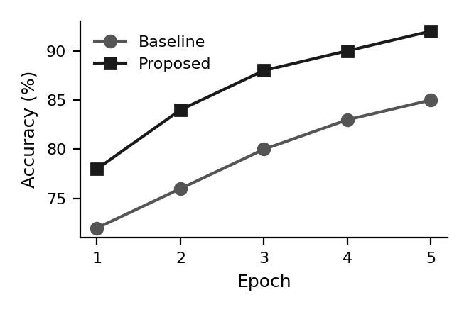
Fig. 1. Example figure caption, replace with your own chart, diagram, or system illustration. Captions for figures are centered below the figure, using 9 pt font, and numbered consecutively (Fig. 1, Fig. 2, ...).
TABLE I. EXAMPLE PERFORMANCE COMPARISON
Method | Accuracy (%) | F1-score
Baseline | 85.2 | 0.84
Proposed | 91.7 | 0.90
Table and figure captions should be placed above tables and below figures respectively, centered, using 9 pt font, with the table/figure number in Roman/Arabic numerals as shown.

V. CONCLUSION
Summarize the main findings and contributions of the paper. Restate how the proposed approach addresses the problem identified in the Introduction, and outline directions for future work. Avoid introducing new results or citations in this section.
ACKNOWLEDGMENT
This section is optional. Acknowledge funding sources, institutional support, or individuals who contributed to the work but do not meet authorship criteria.
REFERENCES
[1] A. Author, B. Author, and C. Author, "Title of the referenced paper," Journal Name, vol. 1, no. 1, pp. 1–10, 2025.
[2] D. Author and E. Author, "Title of a conference paper," in Proc. Int. Conf. on Example Topic, 2025, pp. 100–105.
[3] F. Author, Title of a Book, 2nd ed. City, Country: Publisher, 2024.
[4] G. Author, "Title of an online resource," Organization, 2024. [Online]. Available: https://example.com

